1. **Pre-environmental preparation**
2. **Ready Server**

Two Ubuntu servers are prepared here to ensure that the network connection of each server is normal.The specific environment configuration is as follows:

|  |  |  |  |  |
| --- | --- | --- | --- | --- |
| System | IP | Role | Memory | HostName |
| Ubuntu18.04 | 10.5.32.29 | master | 16G | ic3421-server-1 |
| Ubuntu18.04 | 10.5.32.32 | worker | 8G | ic3421-server-2 |

**2.docker related configuration**

**2.1 Uninstall the old version(if exists )**

$ apt-get remove docker docker-engine docker.io

**2.2 Update apt-get**

$ add-apt-repository "deb [arch=amd64] https://download.docker.com/linux/ubuntu $(lsb_release -cs) stable"

$ apt-get update

**2.3 Install apt HTTPS support package and add GPG key**

$ apt-get install \

apt-transport-https \

ca-certificates \

curl \

software-properties-common

$ curl -fsSL https://download.docker.com/linux/ubuntu/gpg | apt-key add -

**2.4 Install docker-ce**

• **Install lastest version**

$ apt-get install -y docker-ce

**• Install specific version**

#(eg.17.09.1~ce-0~ubuntu)

$ apt-get install -y docker-ce=17.09.1~ce-0~ubuntu

**•**  **Accept all forwarding ip packet**

$ vim /lib/systemd/system/docker.service

#type in following code above ’ExecStart=xxx’：(k8s network requirement)

ExecStartPost=/sbin/iptables -I FORWARD -s 0.0.0.0/0 -j ACCEPT

**•**  **Start service and enable run on start-up**

$ systemctl daemon-reload

$ service docker restart

**3.System Settings(All nodes)**

**3.1 Shut down or disable firewall(allow free connection to servers**

$ ufw disable

#check status

$ ufw status

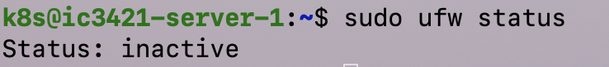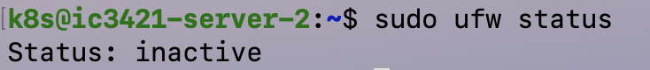

**3.2 Configure Host**

#Configure host so that every node can resolve ip address by name

$ vi /etc/hosts#add following code(replace ip address and server name with yours)

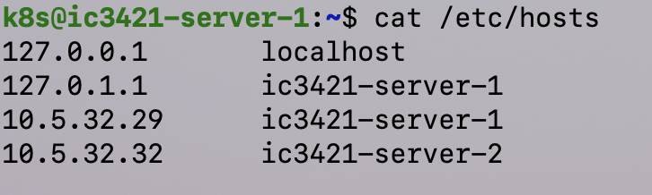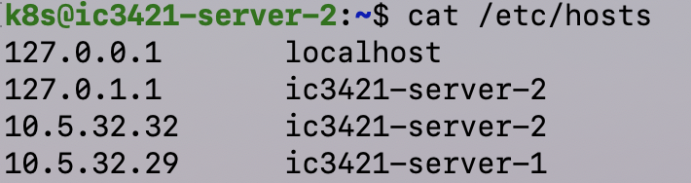

**3.3 Shut Down Swap**

swapoff ‐a

**4.Kubernetes Node Configuration**

**4.1 Install kubelet、kubeadm and kubelet（All nodes）**

#1.use domestic kubernetes mirror

①add apt-key：

curl -s <https://mirrors.aliyun.com/kubernetes/apt/doc/apt-key.gpg> | sudo apt-key add -

--

②add ali mirror:

sudo vim /etc/apt/sources.list.d/kubernetes.list

deb https://mirrors.aliyun.com/kubernetes/apt/ kubernetes‐xenial main

③installation:

sudo apt update

sudo apt install ‐y kubelet kubeadm kubectl

sudo apt‐mark hold kubelet kubeadm kubectl

#2.Use Google official kubernetes mirror

apt‐get update && apt‐get install ‐y apt‐transport‐httpscurl ‐s https://p  
ackages.cloud.google.com/apt/doc/apt‐key.gpg | apt‐key add ‐cat <<EOF>/etc/apt/sources.list.d/kubernetes.listdeb <http://apt.kubernetes.io/kubernetes‐xenial> mainEOF apt‐get update apt‐get install ‐y kubelet kubeadm kubectl

**4.2 Initialize Master**

**·Initialize Master node:**

#Run as root

**Kubeadm init --image-repository registry.aliyuncs.com/google_containers --apiserver-advertise-address 10.5.32.29 --pod-network-cidr=10.244.0.0/16**

**Note:**

--apiserver-advertise-address

Designate exactly which interface of Master for the communication with Cluster.

Clear designation is suggested if Master has multiple interfaces. Otherwise kubeadm will use default interface.

--pod-network-cidr

Clarify the scope of Pod network. Kubernetes supports multiple network schemes with different rules. The cidr should be set as 10.244.0.0/16 for flannel network t. We will try other network in other practice.

For instance, a variable with default value of ‘k8s.gcr.io’ has been appended and the problem in downloading foreign mirrors has been solved in Canal 1.13.

Set the mirror address to ‘registry.aliyuncs.com/google_containers’and recorded relative information as below.

**Master node initialization succeeded:**

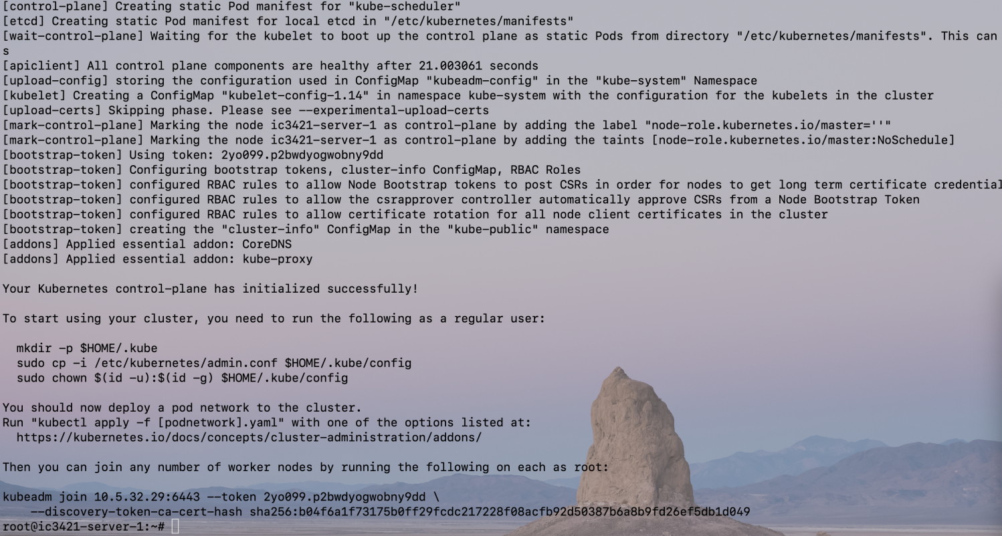

**·Configure kubect for common k8s user**

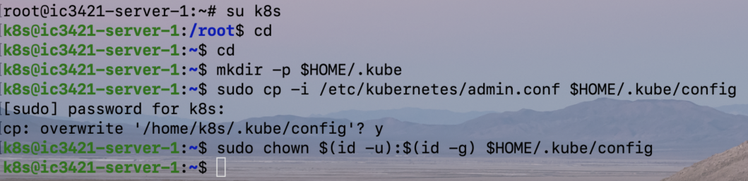

**·Use flannel**

Kubernetes was deployed on Master node through kubeadm in the above paragraph. But in order to get kubernetes Cluster to work, pod network has to be installed. Otherwise connection will not be reached in pod. Though kubernetes supports multiple network schemes, the following commands have to be executed to use flannel

**kubectl apply ‐f [podnetwork].yaml**

Yaml netlist:

**https://kubernetes.io/docs/admin/addons**

yaml with flannel deployed：

**https://raw.githubusercontent.com/coreos/flannel/master/  
Documentation/kube‐flannel.yml**

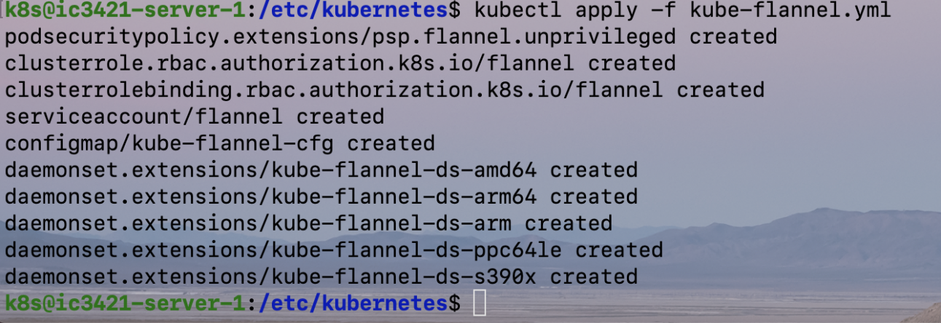

**4.3 Register and add Work node**

Run the following command on node ‘ic3421-server-2’to register it on Cluster:

#Run as root

swapoff -a #disable swap

Kubeadm join 10.5.32.29:6443 --token 2yo099.p2bwdyogwobny9dd

--discovery-token-ca-cert-hash sha256:b04f6a1f73175b0ff29fcdc217228f08acfb92d50387b6a8b9fd26ef5db1d049

Feedback for the this procedure:

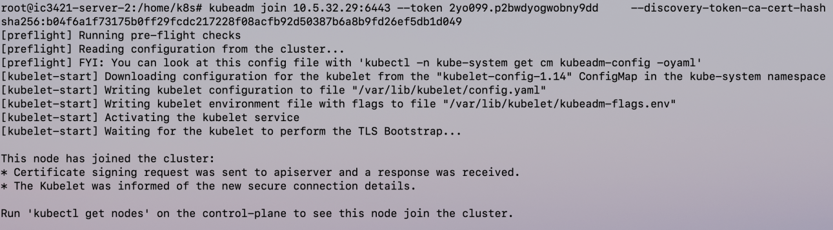

**4.5 Check Cluster status**

Switch to Master node and run kubectl command to check Cluster status.Kubernetes Cluster has been successfully deployed if you get the message below：

#kubectl get node

